Install TCPIP

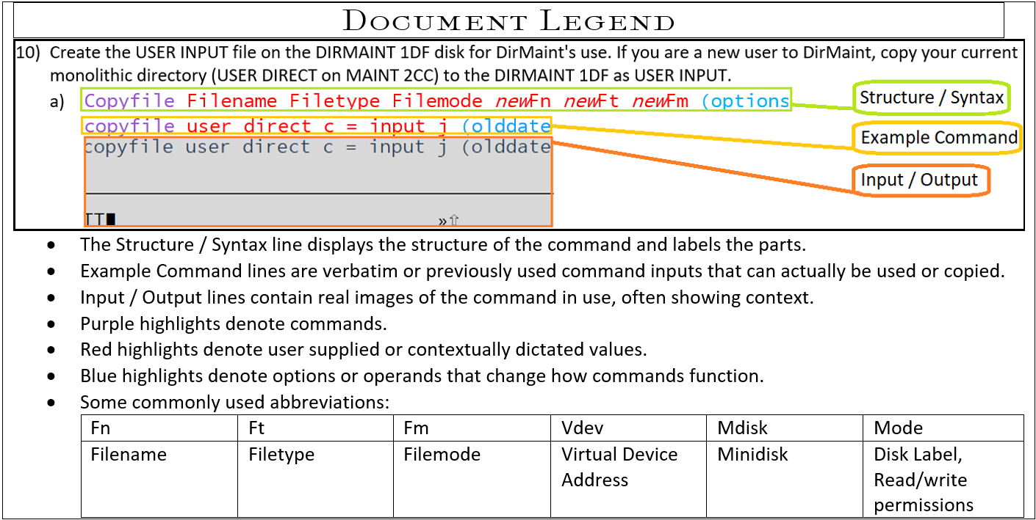

1. Fill out a set of configuration worksheets for each member on which you will create a minimal TCP/IP configuration. Configuration worksheets can be found in Appendix L, “Basic TCP/IP connectivity worksheets,” on page 285.
   1. **Note:** You can use the QUERY CHPIDS command to verify the CHPID associated with your network interface device.
2. Log on to the system as MAINT730.
   1. logonmaint730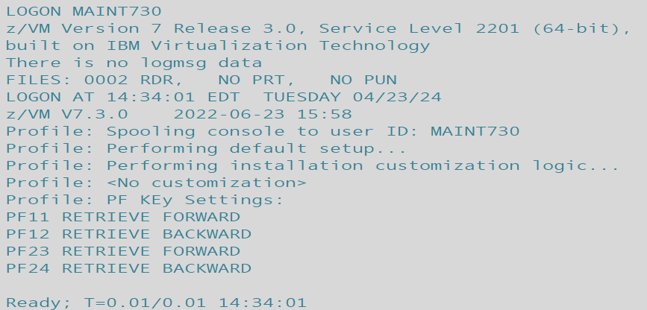
3. Access the minidisk 193 as file mode E.
   1. Vmlink user mdisk  
      vmlink maint 193  
      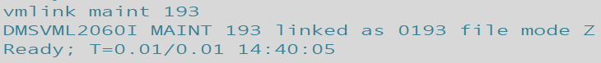
4. Run IPWIZARD.
   1. Ipwizard
5. Using the information you gathered in the TCP/IP configuration worksheets (in Appendix L, “Basic TCP/IP connectivity worksheets,” on page 285), fill in the z/VM TCP/IP Configuration Wizard panel and press F8 to continue.  
   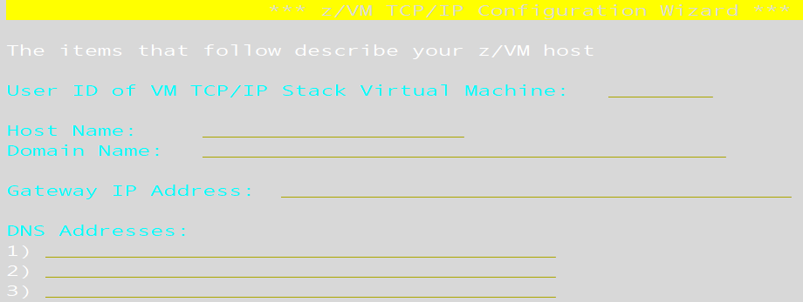
6. Fill in the General Interface Configuration Panel and press F8 to continue. The panel content will depend on whether IPv4 or IPv6 is to be used.
7. Fill in the Interface Configuration Panel and press F5 to process. The panel content will depend on which interface type is to be used.
   1. IPWIZARD attempts to create the TCP/IP configuration files. If the TCPIP user ID is logged on, IPWIZARD asks if you want to restart TCP/IP and continue processing:   
      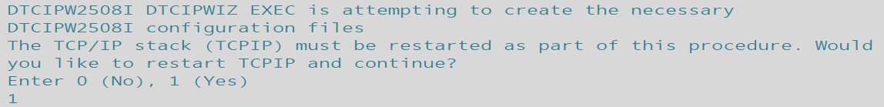
      1. If you continue, IPWIZARD tests the information you provided and returns any errors that occurred. If no errors are encountered, TCP/IP configuration files containing the network information you provided are created. For additional information on configuring TCP/IP, see *z/VM: TCP/IP Planning and Customization*.
   2. Once the pings are attempted if any are missed you’ll be prompted to reattempt. Type 1 to reattempt and standby for output on success or failure.  
      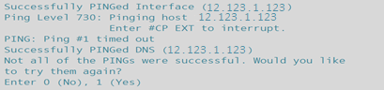
      1. After answering yes, successful output should appear as below:  
         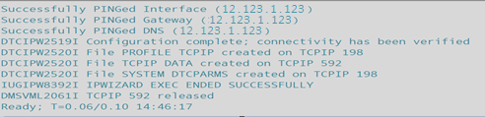
8. The PROFILE EXEC on the AUTOLOG1 191 minidisk contains a commented-out XAUTOLOG statement for TCPIP. Removing the comment characters around the statement will autolog the TCPIP server during CP IPL.
   1. Gain access to the Autolog1 user’s 191 MDISK, Autolog1 191 to open the Profile Exec file and edit it.  
      vmlink user mdisk (options  
      vmlink autolog1 191 (write  
      
   2. Open the PROFILE EXEC in Xedit.  
      Xedit filename filetype filemode  
      Xedit Profile Exec X  
      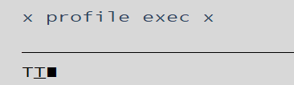
   3. Remove the comment characters from this line:  
      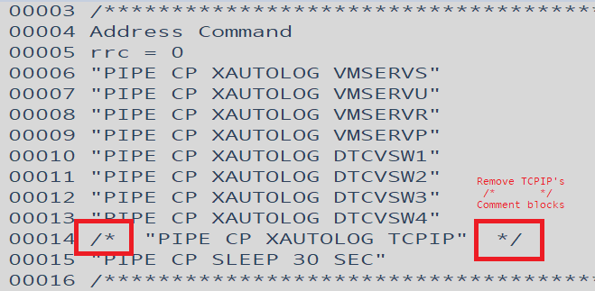
      1. After removal the line should look like so:  
         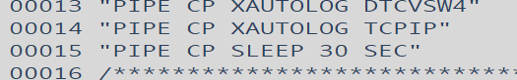
   4. Then save changes with the FILE command.  
      file  
      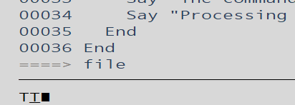
9. If you have a multimember SSI cluster, log on as MAINT730 on each member and repeat substeps “3” on page 92 through “9” on page 93 to configure a basic IP network connection for each member, using the corresponding tables from Appendix L, “Basic TCP/IP connectivity worksheets,” on page 285.

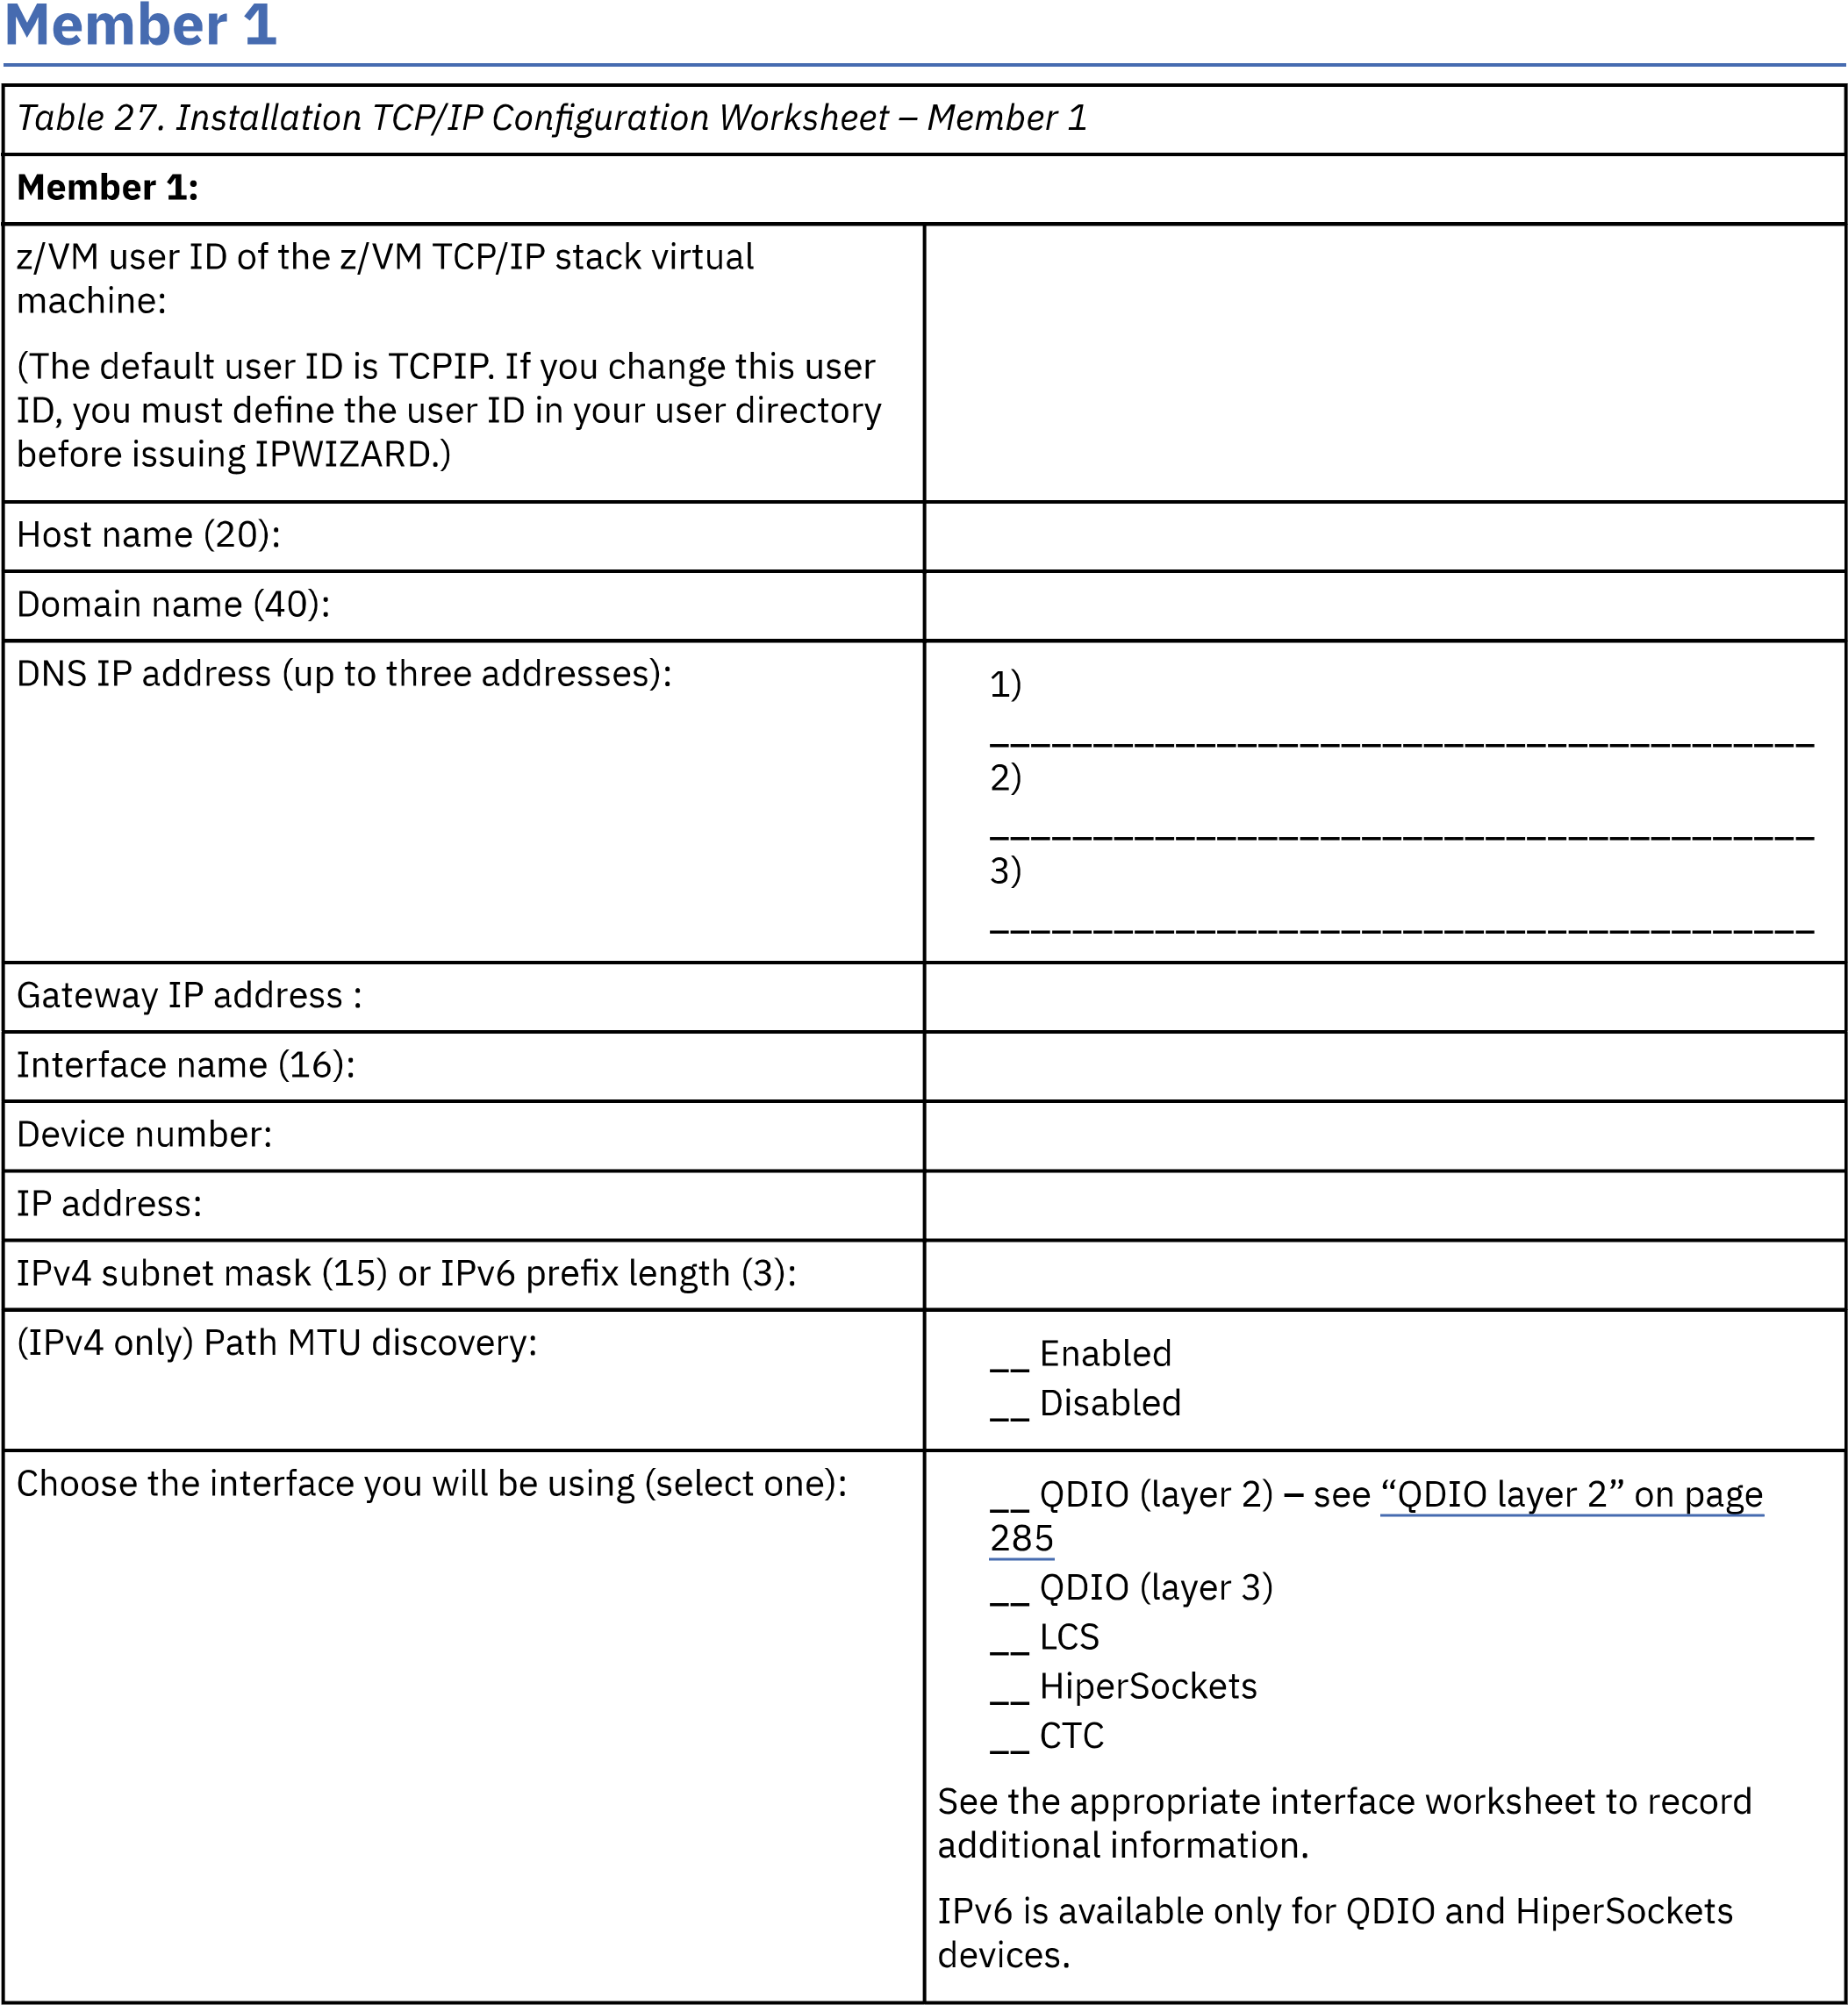

Return to TCPIPStep1